**Registration is now open for summer recreation baseball and softball leagues**

**Summer Recreation Baseball & Softball Registration**

Little Turks T-Ball (age 4-6 / Co-ed): $55.00 Resident -open later date

6U Modified Coach Pitch (Co-ed): $55.00 Resident

Boys 8 & under / Girls 8 & under: $80.00 Resident

Boys 10 & under / Girls 10 & under: $90.00 Resident

Boys 12 & under / Girls 12 & under: $90.00 Resident

***Please note: additional $25.00 fee charged for non-resident***





**NEW: Girls Softball 8u and up will be required to have an infield face mask before first practice.**

**\*REGISTRATION ENDS: 3/31/2023…REGISTER PROMPTLY TO AVOID LATE CHARGES**

**Complete and detach form below. Please don’t forget to sign and date the back!**

**RETAIN TOP PORTION OF THIS FORM FOR INFORMATION ABOUT THE PROGRAM**

**Tremont Parks & Recreation Center – 2023 Registration Form**

Parent Name ______________________ Email ______________________________

Address ___________________________ City ________________ Zip ___________

Home # _____________________ Cell # ________________ Work #_____________

**Emergency Contact: __________________ Phone # _________ Relationship ________**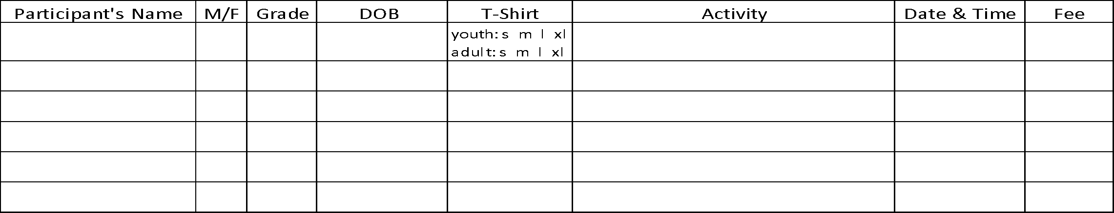



*Once registration is completed, we will establish an evaluation date for those leagues with multiple teams (with the exception of Little Turks T-Ball and 6u Modified Coach Pitch). We ask that registration forms be turned in **as soon as possible** . If you are interested in coaching one of the recreation teams, please indicate that on your registration form. Tremont Area Park District intends to allow **all** children the opportunity to participate. If fees are a concern, please let us know and confidential arrangements will be made.

*Eligibility is based on the child’s age as of May 1st for boys and January 1st for girls. Teams will be formed for ages 4-12 depending on interest. The Little Turks T-Ball & 6U Modified Coach Pitch are co-ed teams. 

**NEW: Girls 8u and up will be required to have an infield face mask before first practice.**

**WAIVER AND RELEASE** -Read Over Carefully

Please read this form carefully and be aware in registering yourself, your child or ward for participation in this program you will be waiving and releasing all claims for injuries you or your minor child/ward might sustain arising out of this program. As a participant in the program or the parent/guardian of a participant in the program, I recognize and acknowledge that there are certain risks of physical injury and I agree to assume the full risk of any injuries, including death, damages or loss which I or my minor child/ward may sustain as a result of participating in any and all activities connected with or associated with such program. I agree to waive and relinquish all claims I or my minor child/ward may have as a result of participating in the program against the Park District and its officers, agents, servants and employees. I do hereby full release and discharge the Park District and its officers, agents, servants and employees from any and all claims from injuries, including death, damage or loss which I or my minor child/ward may have or which may accrue to me or my minor child/ward on account of my participation in the program. I further agree to indemnify and hold harmless and defend the Park District and its officers, agents, servants and employees from any and all claims resulting from injuries including death, damages and losses sustained by me or my minor child/ward and arising out of, connected with or in any way associated with the activities of the program. In case of accident or sickness, I consent to emergency medical care provided by ambulance or hospital personnel. I hereby consent to the use of my photograph in the Park District brochures, publications, slide presentations, etc.

**I have read and fully understand the above Registration Policies and Procedures and Waiver and Release of all Claims.**

Signature of Parent/Guardian ________________________________________ Date ___________________